***EE/CprE/SE 491 WEEKLY REPORT 7***

***10/25/24 - 10/31/24***

***Group number: sdmay25-07***

***Project title: Ask Captain Cyber***

***Client &/Advisor: Doug Jacobson***

***Team Members/Role:***

* ***Ethan Comiskey - Cybersecurity Implementation Principal Manager***
* ***Steven Ragan - Cybersecurity Coordinator & Integration Associate***
* ***Alex Elsner - Lead backend developer***
* ***Casper Run - Cybersecurity and WordPress developer***
* ***Alexander Kronau - Backend developer. Limited Frontend***
* ***Caden Murphy - Frontend developer***

**Weekly Summary**

This week, our team began updating the existing implementation of our project and began adding new features to our Git repository. The front end of our team has utilized React to create a simple landing page for our website and has made progress toward designing a separate page for our experts. We set up SQL buddy for our backend, but we realized it would not suffice for our project needs, so we are looking into alternate solutions. We created a project management dashboard in Git that our team will utilize to track our progress for our tasks. We have begun creating tasks and milestones within the dashboard and will continuously add tasks and assign them as needed. Our goal for the next week is to continue adding and working on these tasks in Git involving setting up our database and developing website components through our React frontend. We also intend to use a WPBot, as shown in Figure 1, to integrate our AI plugin into the project. We are also scheduling a meeting with our advisor, Doug Jacobson, next week.

**Past week accomplishments**

* Ethan Comiskey - Assessed existing Git backend code to see what could be improved and how features could be integrated. Customized Git issue dashboard for project management
* Steven Ragan - Start on a front-end interface through WordPress and set up an IED to work with WordPress.
* Alex Elsner - Worked with Casper Run to integrate WP with git for easy version control and software management. Researched more backend integration with Ambassadors and clarified some details with the Advisor
* Casper Run - Worked with Alex Elsner to integrate WP with git for version control. We ran into issues and will need to work through them. Sent an email out to our faculty about another meeting. Researched WordFence firewall and noted features that will be useful.
* Alexander Kronau - Make significant progress on the Figma mockup for the expert answer vetting page. We also finalized our chatbot UI selection as a WP bot.
* Caden Murphy - Made a simple landing and login page in React

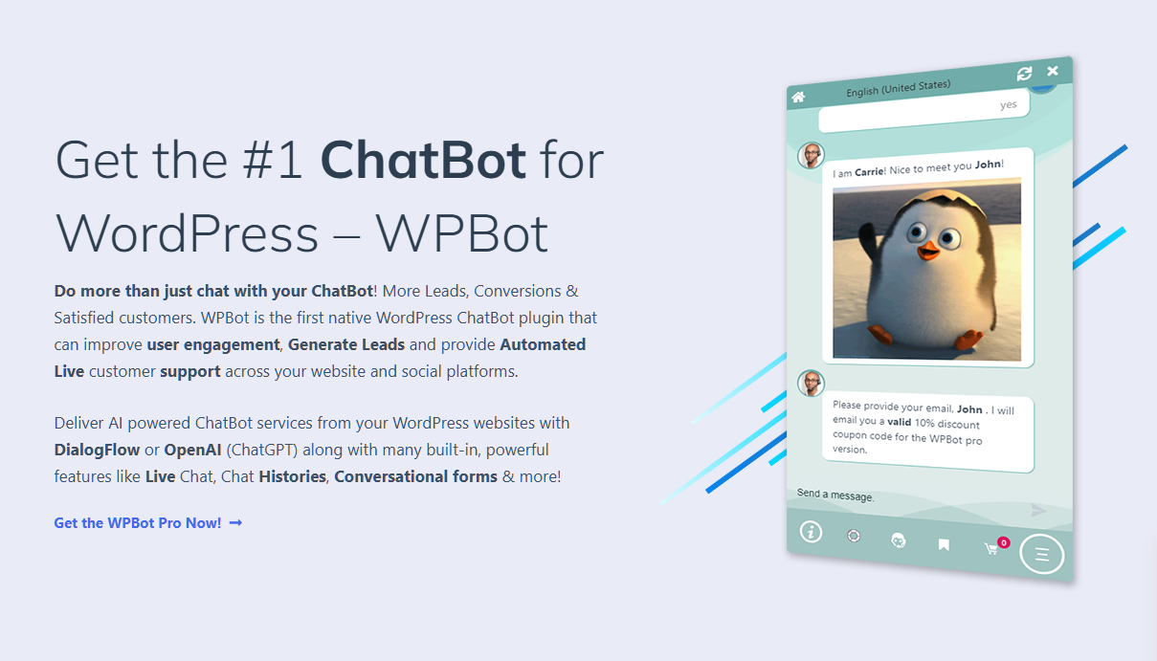

Figure 1: WPBot research to integrate AI into our project

Figure 2: Login Page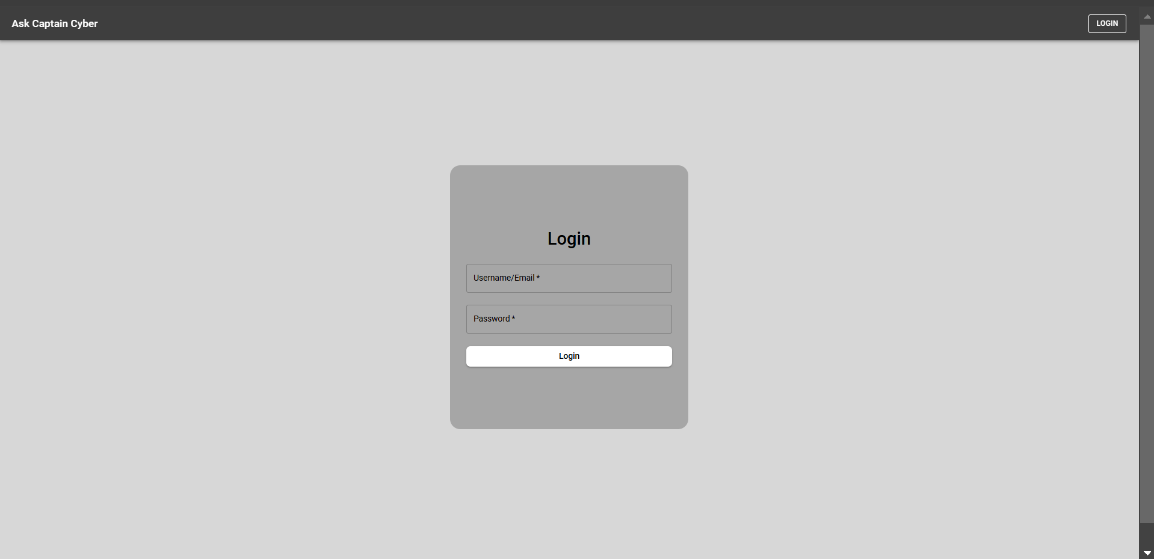

Figure 3: Landing page for Captain Cyber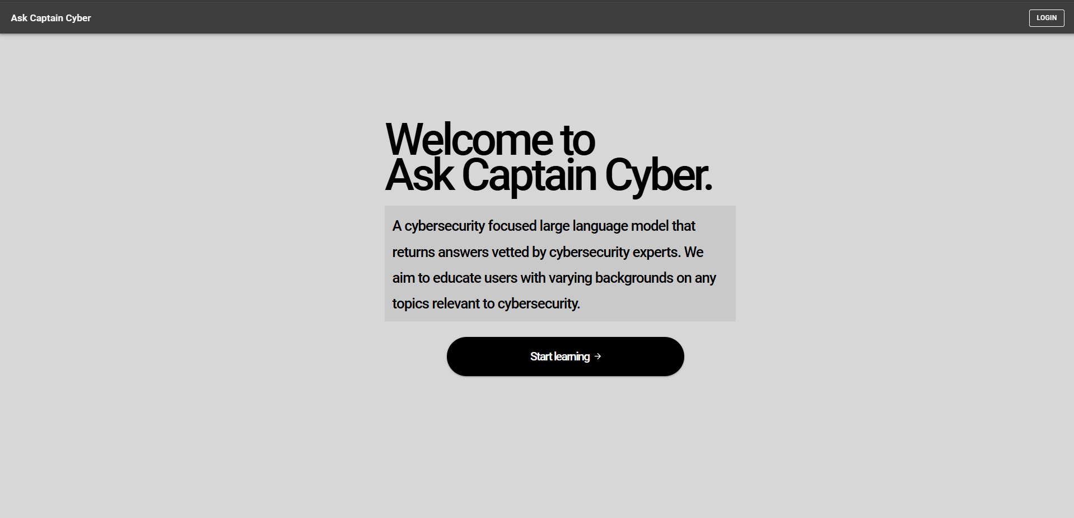

**Individual contributions**

| **NAME** | **Individual Contributions**  *(Quick list of contributions. This should be short.)* | **Hours this**  **week** | **HOURS**  **cumulative** |
| --- | --- | --- | --- |
| Ethan Comiskey | Assessed existing Git backend code. Customized Git issue dashboard for project management | 6 | 44 |
| Steven Ragan | Started WordPress work | 6 | 44 |
| Alex Elsner | Figured out how to integrate WP local with git. Researched how to integrate DB for users. | 6 | 44 |
| Casper Run | Integrated WP local with git. Set a meeting with Doug for next week. Researched useful features in WordFence. | 6 | 44 |
| Alexander Kronau | Finalized that WP bot will be the primary support for Captain Cyber. Continue working on expert vetting page mockup in Figma. | 6 | 44 |
| Caden Murphy | Made Landing and Login page in React, looked into Auth0 for login authorization  [https://developer.auth0.com/?_gl=1*18bor6j*_gcl_au*MTY0NjIzNzYyNy4xNzMwNDA0NzUw*_ga*NTM4OTY5MjQxLjE3MzA0MDQ3NTE.*_ga_QKMSDV5369*MTczMDQwNDc1MC4xLjEuMTczMDQwNjE0OC4yMS4wLjA.](https://developer.auth0.com/?_gl=1*18bor6j*_gcl_au*MTY0NjIzNzYyNy4xNzMwNDA0NzUw*_ga*NTM4OTY5MjQxLjE3MzA0MDQ3NTE.*_ga_QKMSDV5369*MTczMDQwNDc1MC4xLjEuMTczMDQwNjE0OC4yMS4wLjA.) Which could be pivoted to use ISU’s infrastructure if needed. | 6 | 44 |

**Plans for the upcoming week**

* Ethan Comiskey - Research ways to potentially test the AI plugin before purchasing a license to verify the AI will work and integrate with our project as expected.
* Steven Ragan - Come to some understanding about implementing AI within the WordPress local server.
* Alex Elsner - Try to get the first user/admin table set up in the database and figure out if we need to program any DB ourselves. Try to figure out how to connect the UI to the database. Get Git set for the development environment.
* Casper Run - Help Alex Elsner get Git set up properly for development by making sure we can push and pull with no conflicts. Configure the WordFence Firewall for the project. Assist Alex with database development and creating documentation for setting up a development environment for the project.
* Alexander Kronau - Finish the mockup for the expert answer vetting page. Begin React implementation.
* Caden Murphy - Continue researching and implementing WordPress to React Frontend based on the provided source code. Continue building essential website components, including potentially using Auth0 for expert logins or the ISU services.